Central and Northern Florida

District 84
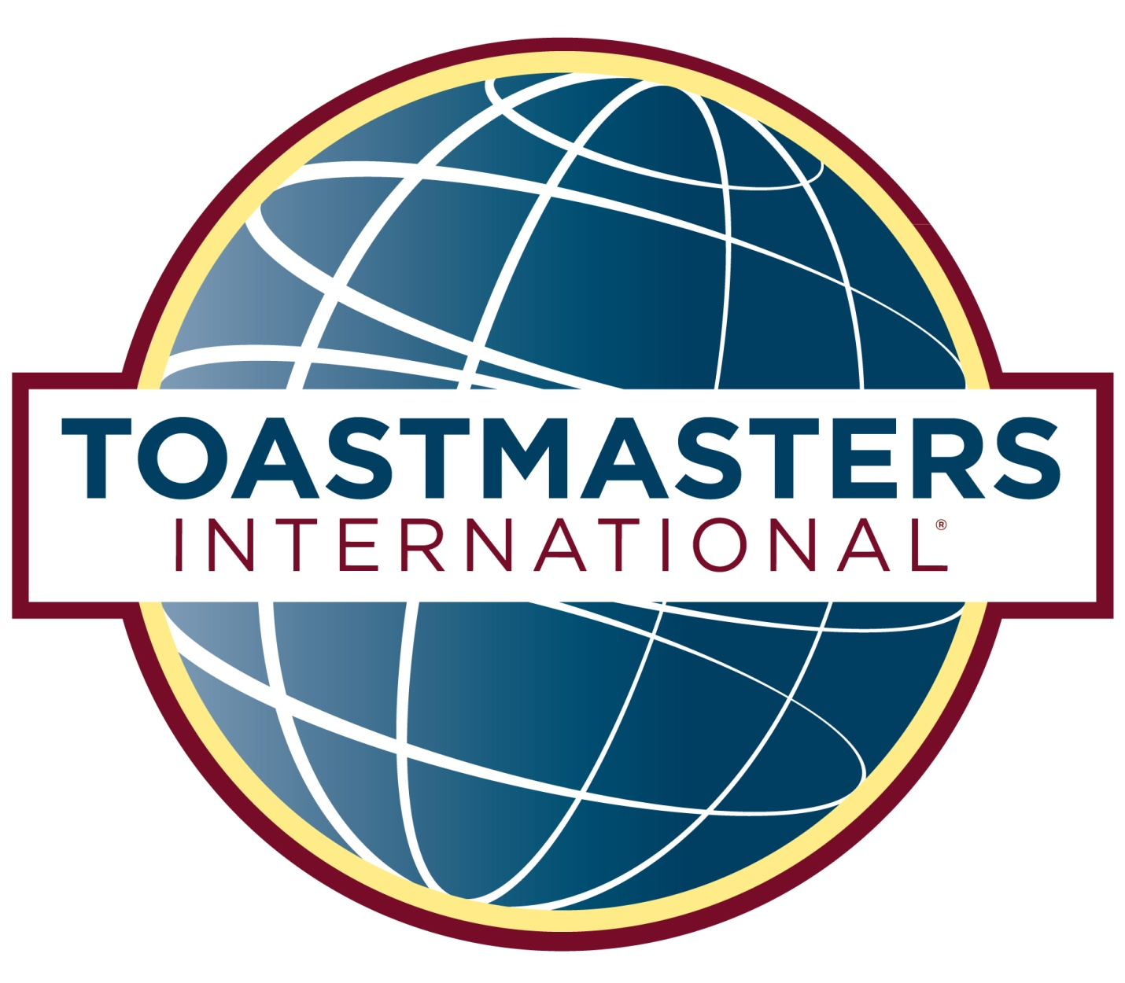

Conference Sponsorship
Opportunities
A powerful marketing opportunity with tax-deductible benefits available now to noteworthy members of Florida’s business community.

Toastmasters International is a world-wide, non-profit organization of over 357,000 members in over 145 countries. Ours is the only organization “Where Leaders are Made” - dedicated solely to improving individual communication and leadership skills in a fun-filled and positive learning environment.
Take advantage of the Annual District 84 Toastmasters Conference: “Under the Big Top” scheduled for May 5-6, 2023 at The Shores Resort and Spa in Daytona Beach. We anticipate broad attendance from our more than 3,000 members representing North and Central Florida - from Winter Haven/Sebring in the south and north to Tallahassee, east to Jacksonville and down the Atlantic coast to Vero Beach.
The marketing opportunities for your business are numerous. As a Conference Sponsors you can share your important products and/or services with our dynamic members from every walk of life - members who are talented, enthusiastic, and passionate about improving themselves personally and professionally. Network with this targeted audience as they peruse the exhibit area on their way to select champions in three speech contests, participate in multiple educational workshops and discussions, and celebrate outstanding member awards and recognitions.
Please review the following information about the different participation levels. A registration form is also included. We have made participation easier than ever by setting up all-in-one discount packages and “á la carte” items to give you the most value for your contribution. It is your choice to determine which best suits your needs.

We thank you in advance for your invaluable support of this non-profit educational organization. Our success depends on the support of businesses and organizations like yours. To make it easy for you, we are providing this link to submit sponsorship information online using this jot form link: https://form.jotform.com/230074439201143, or you may complete the form at the end of this packet and mail or email to me.
We look forward to hearing from you.
Respectfully,
Vickie Goodman

Vickie Goodman, DTM
Program Quality Director
District 84 Toastmasters
vgoodmandtm@gmail.com

Platinum — $1,500
- Two conference VIP registrations for Friday and Saturday night banquets
- Reserved Premium exhibit location, with one 6-foot, skirted table, two chairs and option for additional floor
- Full-page, color advertisement in annual conference book
- Boldface listing with business description in the exhibitor directory in the conference book
- Inclusion of company-provided branded giveaways in participant swag bags.
- Logo prominently displayed in print and media during event
- Logo placement in printed conference banquet programs

Gold — $1,000
- One conference VIP registration for Friday and Saturday night banquets
- Featured 6-foot skirted display table and two chairs
- Half-page color ad inside the conference book
- Listing of business name in the exhibitor directory in the conference book
- Inclusion of company-provided branded giveaways in participant swag bags.
- Logo prominently displayed in print and media during event
- Logo placement in printed conference banquet programs

Silver – $500
- Featured 6-foot skirted display table and two chairs
- Listing of business name in the exhibitor directory in the conference book
- One ¼ page full color ad in the conference book
- Logo placement in printed conference banquet programs
- Inclusion of company-provided branded giveaways in participant swag bags.
- One VIP conference registration for Friday OR Saturday night banquets

Bronze – $250
- Featured 6-foot skirted display table and two chairs
- Listing of business name in the exhibitor directory in the conference book
- One ¼ page full color ad in the conference book

Á la carte
- Back cover ad in Conference Book — $500
- Full-page ad in Conference Book — $130
- Half-page ad in Conference Book — $80
- Quarter-page ad in Conference Book — $50
- Eighth-page ad in Conference Book — $30
- Your branded giveaway item placed in Swag Bag given to all attendees. You provide the Give Away and we will include a complimentary eighth-page sized “Thank You” Ad in the Conference Book — $50

To make it easy for you, we are providing this link to submit sponsorship information online using this jot form link:
https://form.jotform.com/230074439201143,
or you may complete the form below and email to District 84 Finance Manager: tmdivcdir@gmail.com
District 84
Sponsorship Application
Return to: D84 Finance Manager- tmdivcdir@gmail.com
Please complete this form to reflect your company's information as you would like it to appear in our publications.
Company Name: _______________________________________________________________
Contact Name: ____________________________ Title: _______________________________
Address: _____________________________________________________________________
City: ______________________________ State: ________________ Zip: _________________
Phone: ____________________________ Fax: ______________________________________
Email: _______________________________________________________________________
Website: _____________________________________________________________________
Type of Product/Business/Service: ________________________________________________
IMPORTANT NOTE ABOUT DUE DATES: Platinum, Gold, Silver and Bronze sponsorship levels are due by April 1st for inclusion in the D84 CONFERENCE PROGRAM.

Please indicate your sponsorship level:
Check one: PLATINUM $1,500
GOLD $1,000
SILVER $500
BRONZE $250
A LA CARTE $________
TOTAL $________

If you have indicated an A La Carte item please specify below:

Credit Card: M/C — Visa — American Express
Card Number: ________________________________________________________________________
Exp. Date: ___________________ CCV _________________
Name on Card: ____________________________________
Billing Address: ________________________________________________________________________

Meals or additional attendee registrations for the CONFERENCE may be purchased individually. See www.toastmastersd84.org for details.

